  - Central Falls High School
  - Expanded Learning Opportunities
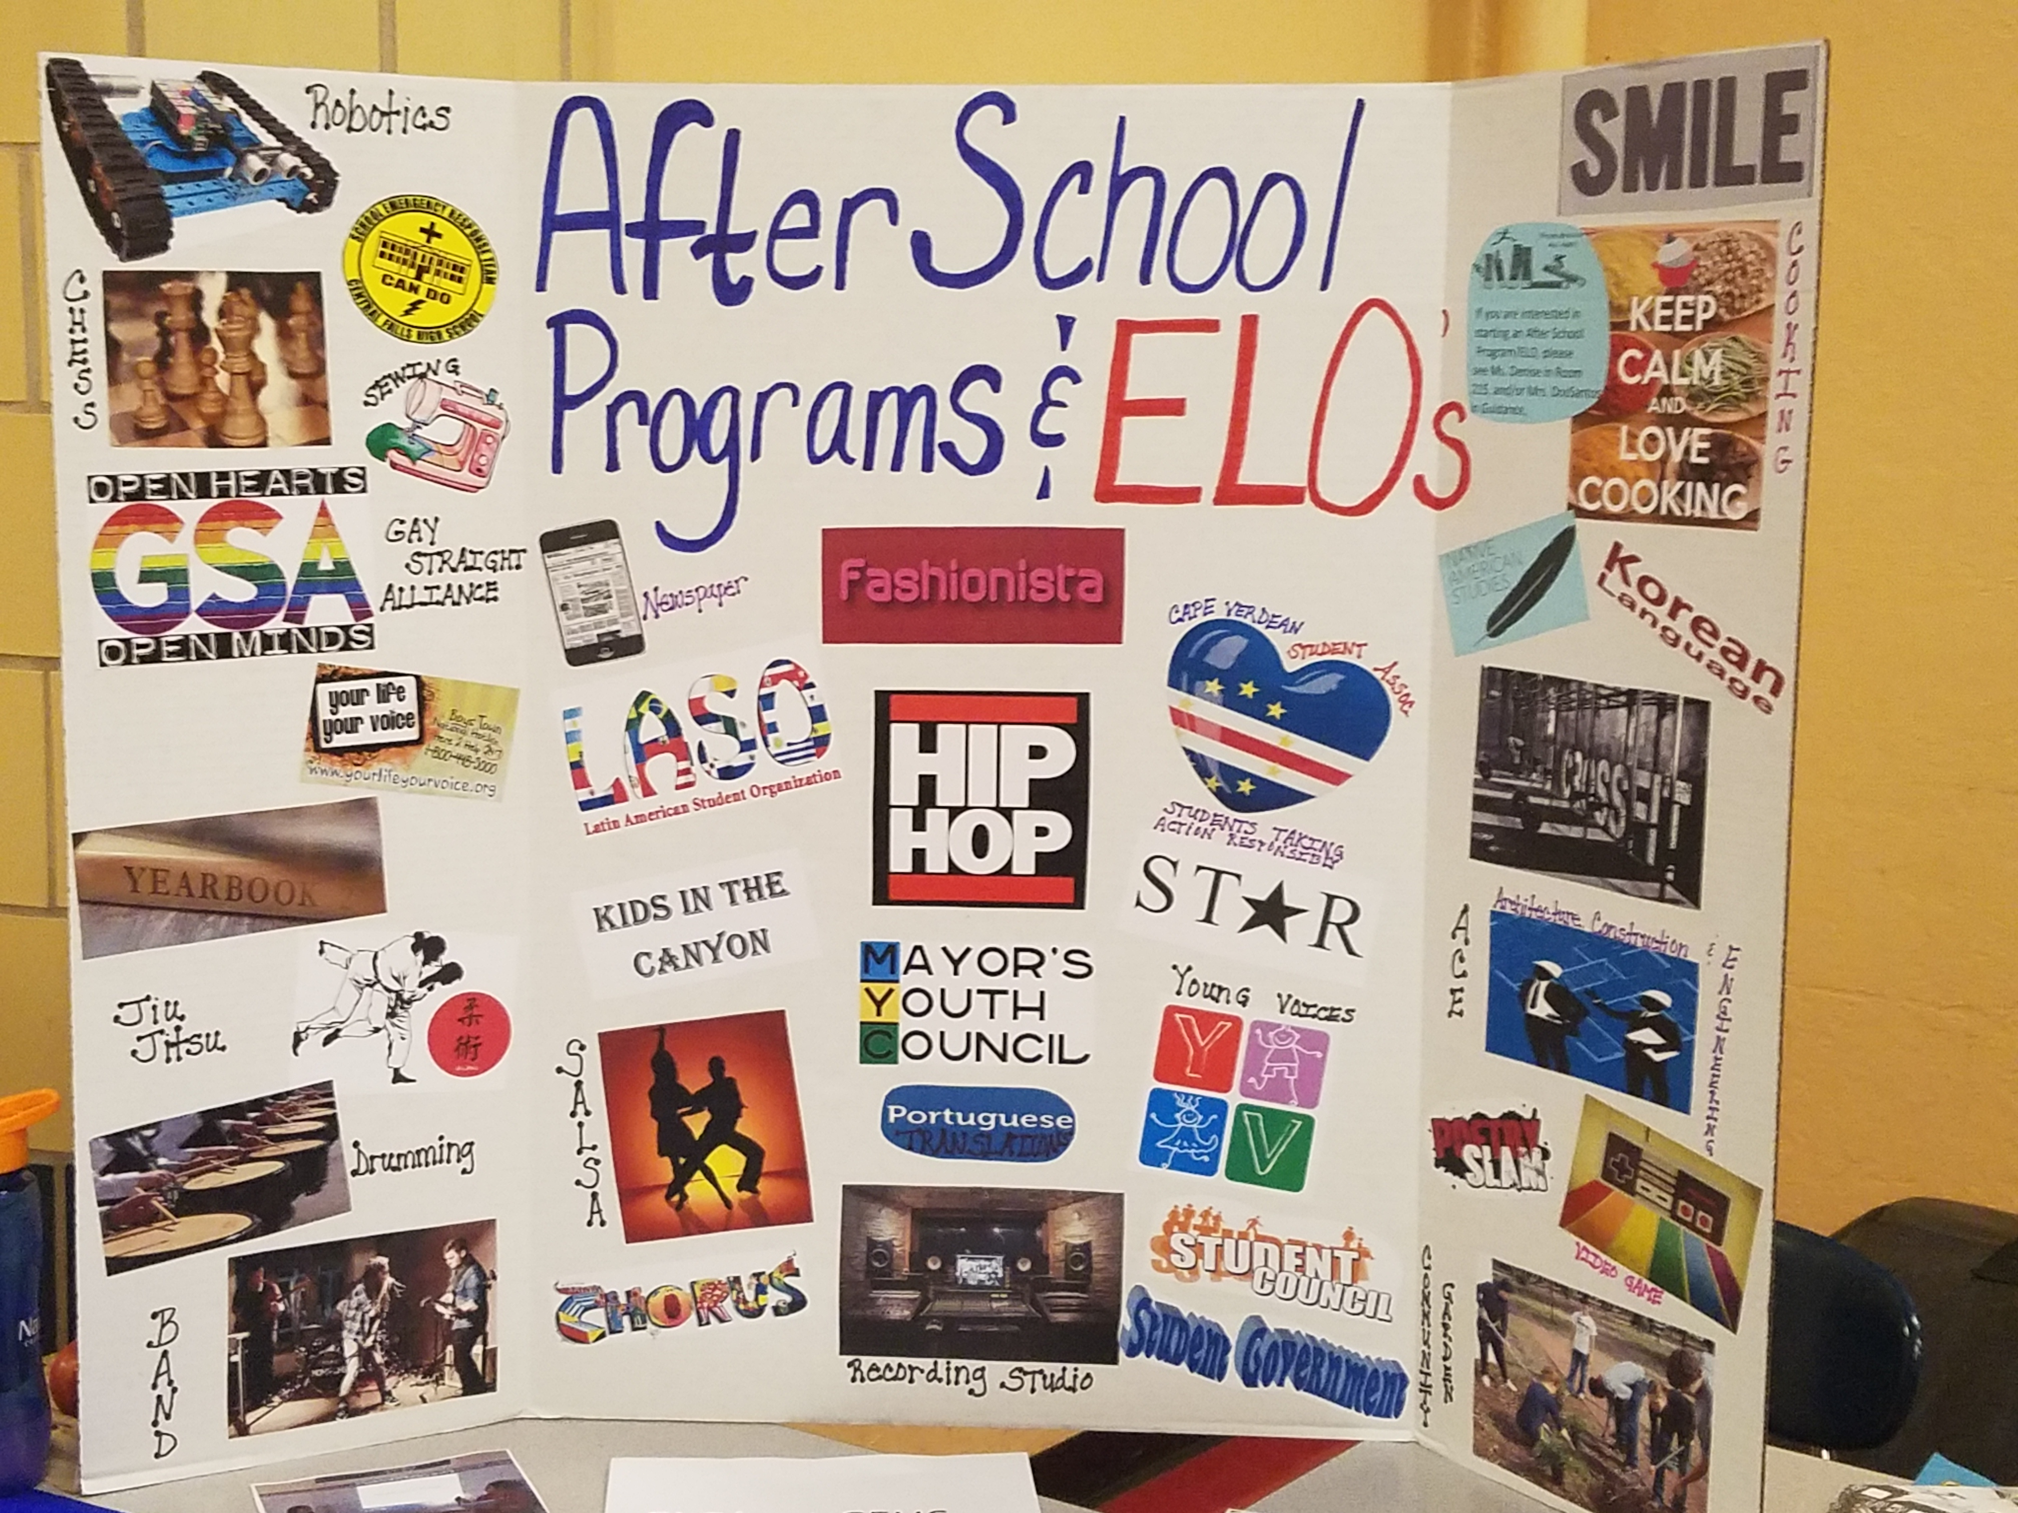
2017-2018

This handbook is designed for students, teacher mentors, and community partners who are working together to design Expanded Learning Opportunities for credit for individual or groups of students.
The Expanded Learning Opportunities (ELO) Initiative at Central Falls High School provides an opportunity for students to get academic credit for learning that is student-centered, hands-on, and rigorous. Students that participate in ELO’s work closely with teachers who are highly-qualified in the subject of the ELO and community partners who provide students with the chance to apply their learning in a real-world setting.
Some forms of ELO’s take place during the school day as part of the standard curriculum and other ELO’s take place after-school or during the summer and are driven by students’ particular interests and passions. When completing an ELO, students work as individuals or in groups.
In order to complete an ELO, students complete ongoing reflections, research, create a final product, and demonstrate their learning at a final presentation.
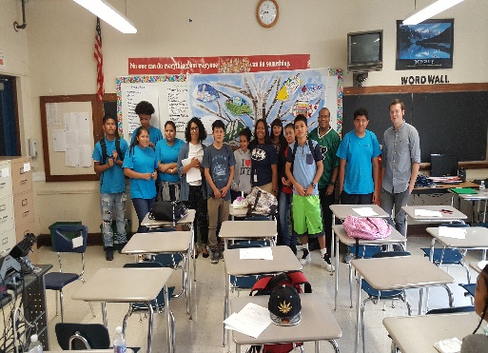
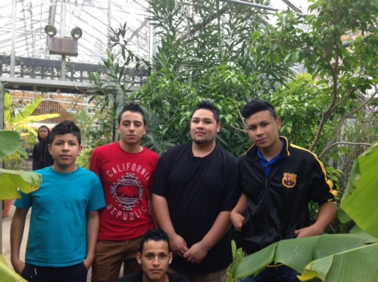

We believe:
ELO’s can be in ANY subject and for ANY student.
Students learn best when they participate in the design of their learning.
Learning can take place at all times of the day, in all different kinds of environments, and in different ways.
Teachers are critical to the ELO process—they ensure that the learning is based on academic standards.
Community partners are instrumental to experiential learning that helps students to apply their learning in real-world settings.
Learning can be simultaneously individualized to a student’s learning style and academically rigorous.
High-quality learning requires the collaboration between school, community, and families.

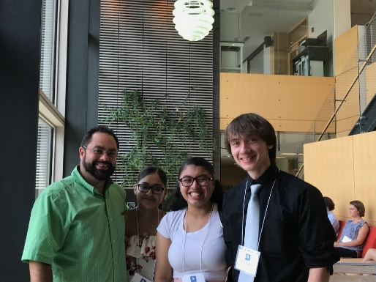
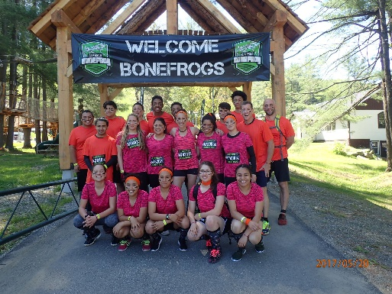

In addition to ensuring that students meet or exceed proficiency in required learning standards and providing students with opportunities to pursue their passions, ELOs help students develop 21st Century Skills, including: critical thinking, creativity, innovation, flexibility, ethical and collaborative problem solving, effective use of applied technology, and interpersonal and leadership skills.
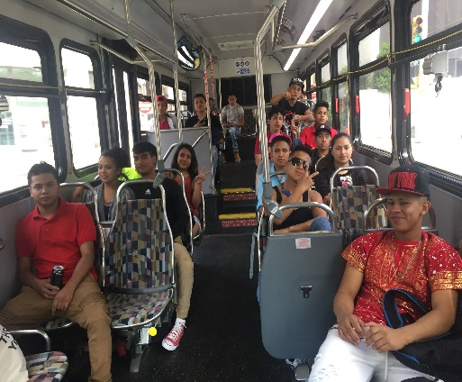

Frequently Asked Questions
Who can participate in an ELO?
Students can participate in an ELO because they want to: 1) Study a topic that is not taught in school; 2) Pursue an issue that they are passionate about or would like to gain experience in a potential career pathway; 3) Make up a credit; 4) Complete a class that does not fit into their schedule; 5) Learn outside of a traditional classroom setting.
What is the process for a student to participate in an ELO?
Prior to beginning an ELO a student must:
1. Meet with The ELO Director to review the ELO process and expectations
2. Interview with a Teacher Mentor and Community Partner
3. Work with The ELO Director, Teacher Mentor and Community Partner to design the ELO (using the ELO Planning Tool)
4. Inform parent/guardian and Guidance Counselor about a prospective plan for an ELO

Now, you are ready to officially begin your ELO!
Can an ELO project be used as an artifact in the Performance Based Graduation Requirement Portfolio (PBGR)?
Yes, if the project is approved by the Performance Based Graduation Requirement (PBGR) Committee as a valid task. In the ELO Planning Tool, students and Teacher Mentors should list the Performance Based Graduation Requirement (PBGR) that is covered in the ELO.
What must a student do in order to receive a credit for their ELO?
After completing the planning stage of the ELO program, the student must meet with his/her mentors on a regular basis (once per week is recommended). The student must complete weekly reflections and benchmark activities, meet a level of proficiency in the required standards as demonstrated through assessments, design a final product, and give a presentation about their learning process in front of a panel that consists of the ELO Director, Teacher Mentor, Community Partner, and may include the school counselor, a CFHS administrator, family members and friends. The student must receive a score of 3 or 4 (proficient or exemplary) on each requirement in order for their ELO to count as a credit. If the ELO is serving as credit recovery, the ELO must meet the same competency requirements of that particular subject. The panel provides feedback to the students and the Teacher Mentor who determines the final grade, which is then submitted to guidance.
Can an ELO replace a class that a student is currently failing?
No, if a student is participating in an ELO project to make up a missing credit, it cannot be for a class s/he is currently failing. However, the ELO Director can work with the teacher and student to devise project-based learning that the student can complete during class time that fits his/her needs as a learner and a previously earned ELO is always eligible to be applied to a content need if the core requirements were met per the ELO Tool with all involved members.
How long does it take for a student to complete an ELO for credit?
ELOs for credit take different amounts of time based on the project plan. ELOs are standards-based, not time-based. This means that students complete their ELOs when they have met all of their learning goals. To ensure that students have enough time to plan their ELO and build relationships with their mentors, the minimum time that a student can complete an ELO for a full credit is one full quarter (10 weeks). If a student wants to do a smaller project as part of a larger class or for a portfolio task, or has a special exception, the ELO Director will work with the student and his/her mentors to apply the appropriate policy modification for that student. The ELO Director will work to help place a student who may be interested in a community-based learning experience such as a one-time job shadowing experience, a community service project, or an extended internship at a job site.
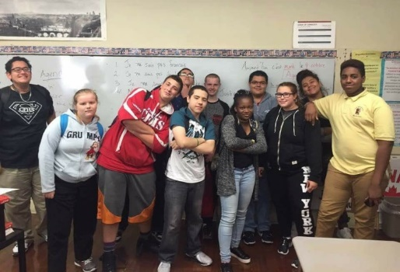
What are some examples of ELO final projects that students at Central Falls High School have completed?
- Committed to a research program at Providence College alongside college students and professors in The Bio Chemistry Field and presented findings at the 10th Annual RI SURF Conference
- Studied the Italian Language and presented a Power Point exhibition of work
- Created an Oral History Report of Central Falls History as an exhibit
- Hiked the Grand Canyon
- Students participated in a hands on Science and Mathematics course in Mechanical Fabrication and Hydroponics in conjunction with The Center for Dynamic Learning
- Researched and participated in hands-on learning experiences in community gardens
- Studied the dance theory and practice of Salsa at CFHS as part of joint credit at Brown University

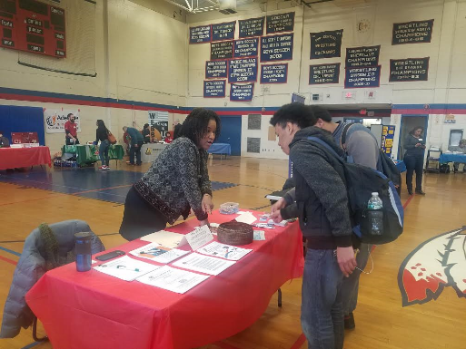

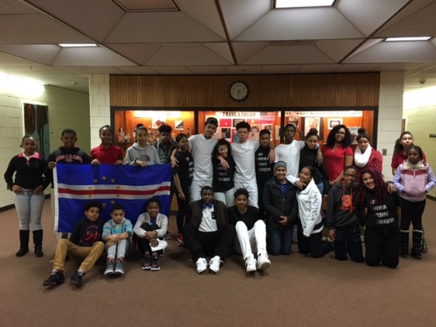

required Documentation

Filled out by a student with Mentor support
__Interest Form
__Parent/Guardian Permission

Filled out by Community Mentor
__Community Mentor Interest Form
__Confidentiality Form
__Volunteer Protocol Form
__Planning Tool
Filled out by teacher and community mentors and student
__Agreement Form
__Planning Tool

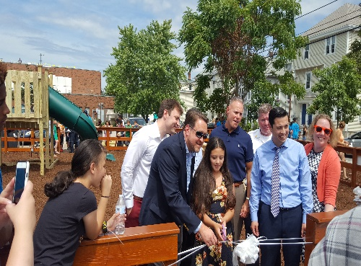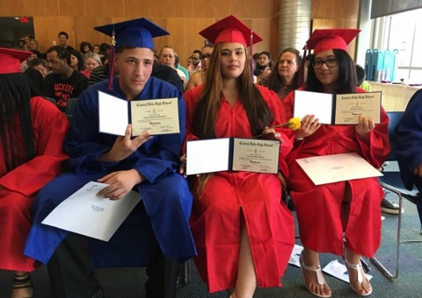

An ELO is a collaborative process. The key to the success of an ELO is the student’s involvement in all aspects of the experience—including development of a plan and learning goals and the assessment of learning. The following describes the roles of various individuals in the ELO assessment process:

ELO Roles and Responsibilities

Student

- Works with ELO Director, Teacher Mentor and Community Partner to design the ELO Planning Tool
- Completes reflections to assess progress on the ELO and to identify next steps in learning
- Communicates regularly with Community and Teacher Mentors as well as with the ELO Director
- Follows through on timelines that are set for assignments, self- assessment/reflections, and final assessment of learning

Teacher Mentor (certified in subject matter of the ELO)
- Identifies competencies (what the student needs to learn) with the student
- Collaborates with the student to define how the student will be assessed on those competencies
- Assesses student’s mastery of pre-determined content (competencies), including input from Community Partners and student
- Oversees the ongoing and final assessment of student progress using rubrics and provides frequent feedback to the student regarding progress
- During meeting with student: reviews student’s reflections, helps troubleshoot if any issues have arisen, and provides leadership for the student’s research.
- Completes progress reports

ELO Director

- Oversees ELO orientation and workshops
- Connects students to mentors.
- Clarifies the role of each person in the ELO planning process
- Ensures that the assessment rubrics are utilized in all ELOs
- Provides access to resources

Community Mentor

- Support and coach students in their ELO experience
- Provide the student with timely, detailed feedback to develop skills, knowledge, problem-solving ability, creativity, and complex thinking, while reflecting on their learning
- Serves as a rich source of knowledge and experience in the project area.
- Completes progress reports

Parent
/Guardian

- Student success is linked to family involvement and encouraged throughout the ELO process
- Becomes familiar with all aspects of the ELO process

ELO Policies and Procedures
Community Sites/Partners
Students can only perform work that is approved by Rhode Island Department of Labor and Training for their age group.
In order to serve as a mentor, the community partner must fill out the necessary paperwork and provide a copy of BCI clearance.
A relationship with a community partner can be stopped at any time by the ELO Director or CFHS Administration if the community partner is not abiding by the rules specified in the CFHS volunteer protocol, there is evidence to believe the student is not safe, or the motives for the community partner are not clearly aligned to the values of CFHS and the ELO Initiative.
Behavior and Attendance
Participating in an ELO is a privilege. To successfully complete an ELO a student will have to demonstrate self-respect and respect of the school and larger community, self-motivation, clear and consistent communication, a willingness to learn, and a strong work ethic.

If a student is leaving the school building for an ELO related meeting or event, s/he needs to submit a permission slip signed by a parent/guardian and the teachers of all classes the student will be missing.

If student has to cancel a meeting with the ELO Director, Teacher Mentor, or Community Partner, s/he needs to contact them 24 hours in advance to reschedule.

If based on community, teachers, and student progress reports, a student is not meeting learning benchmarks and goals, it is required that the student holds a meeting with a family member, the ELO Director, his/her Teacher and Community Mentors, school counselor, and advisor to determine what is causing the lack of success and to make a plan for ways the student may get back on track. The student will be required to submit a letter of intent demonstrating his/her commitment to their learning. If the student continues to not reach learning goals after 6 weeks, the student will have to re-assess his/her ability to successfully complete the ELO and if they are unable, will have to resume it at a later time when they are ready to make the commitment.

Assessment
All assessments must have a rubric that the student receives prior to beginning an assignment. This is to ensure that the student understands the necessary steps to achieve proficiency and that the assessment is a fair process. Please see the next section of the ELO Handbook, entitled “ELO Planning Tool Explained” for specific assessment requirements. Assessments used are either school-wide assessments, teacher-designed assessments or ELO assessments. If there is not an available rubric for a particular student’s project, the ELO Director and an Administrator will work with the Teacher Mentor and student to design an appropriate rubric. It is important that after each benchmark activity, a student assesses him/herself because we value what is called “assessment as learning,” or when a student is able to personally monitor his/her own learning and use those reflections for future growth.

Grading
A student participating in an ELO to obtain a credit for a core class requirement will receive a letter grade. A student who is participating in an ELO for enrichment may decide with the guidance of their mentors and families whether they would like to receive a letter grade for their ELO work or a Pass/Extend. If you get an “Extend” this means that you need to continue to work on your project. It is the role of the teacher mentor to explain to the student how their score on a rubric will be translated into a letter and number grade.

If a student has not achieved the level of competency that is required to master the standards, they continue to work on their project. If after the final “Presentation of Learning” the panel decides that the student’s work is not up to the standards, the student makes a plan with the Teacher and Community Mentors and ELO Director to finish this work, and when it is complete the student presents the ELO again to the panel for a final grade.

Confidentiality
No identifying information regarding any student will be disseminated to the community partner without the prior written consent of the student’s parents or, if the student has reached the age of majority, by the student. A community mentor can only meet individually with a student after s/he has completed all mandatory forms and provided a copy of an approved BCI clearance.
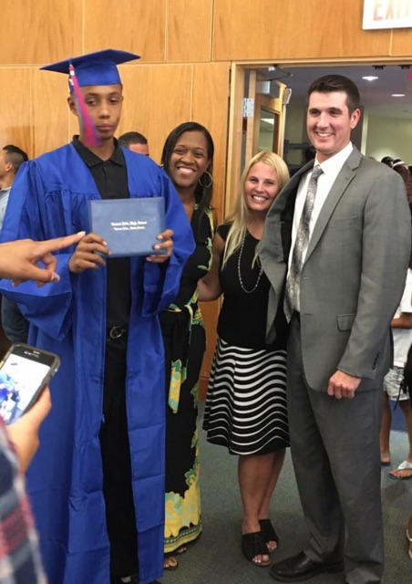
Diverse Learners
The ELO process is open to all students in the high school inclusive of students who are identified as receiving special education services as well as English Language Learners. Case managers for these students will be part of the development, implementation and evaluation of the individual ELO as applicable and necessary.

Students with current Individual Education Plans (IEP’s) who request an ELO for credit recovery will be referred to their case manager as part of the process of approving the ELO. The case manager will be responsible to ensure that the student receives the necessary accommodations and support in order to successfully complete the ELO.

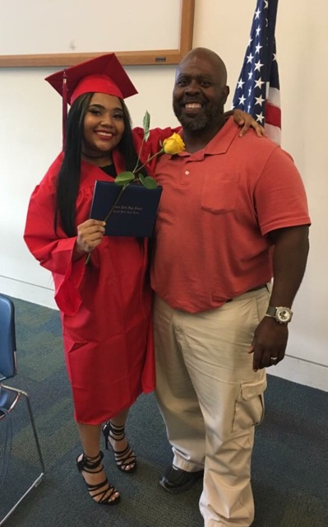

ELO Planning Tool
The ELO Director will work with the student, teacher mentor, and community partner to complete the Planning Tool. It provides a way to document the standards that are necessary for students to become competent and receive credit for their work; ensure that the benchmark activities are aligned to standards; and demonstrate how the student will be assessed.

Here are some parts of the Planning Tool explained:

Vision: When describing your vision, is it important to dream big! What is your plan for your ELO? What do you hope to learn? What type of experiences do you want to have?

Essential Question: What is the essential question that will drive this ELO project? An essential question does not have a yes or no answer—it will take research, reflection, and conversations. It will drive you to be curious and challenge your assumptions. The question should be broad enough so that it cannot be answered easily and can be approached from many different entry points.

Competencies: These competencies should be based on the Common Core Standards and PBGR’s (Central Falls High School Performance Based Graduation Requirements). If there is not a school-wide or state-wide set of competencies for the subject of a particular student’s ELO, the ELO Director and an Administrator will work with the Teacher Mentor, Community Partner, and student to determine an appropriate set of competencies.

Research: Research is a requirement of every ELO and the student needs to keep a list of research used. The student will decide with their mentor whether they will record your sources using MLA format, but at the very least the student must record the name or site address, date, and author. Research can consist of interviews, book chapters, articles, website analysis, group discussions, etc.

Assessment: ELO Research Rubric, if demonstration of research is in paper form: use school-wide Formal Report of Information Rubric

Reflection: Reflections allow students the opportunity to think about their experiences and "get the learning out" of these experiences. Through reflection, students develop and adjust their short and long term goals, explore problems and solutions encountered during their ELO’s, and connect their experiences to their learning goals. Reflections are an important part of the feedback loop between the student and their teacher advisor/community mentor.

Assessment: Students will e-mail or hand in reflections to Teacher Mentor, Community Partner, and ELO Director as agreed upon per the ELO Planning Tool. Mentors provide written and/or verbal feedback at the beginning of the ELO, midway through the ELO and at the conclusion of the ELO. At the conclusion of the ELO, students will turn in their reflections to be assessed according to the ELO Reflection Rubric.

Benchmark Activities: Through the ELO, the student will be completing benchmark activities that demonstrate proficiency in the required standards if their ELO Plan includes this detail. These series of small projects provide a foundation to complete the final project.

Assessment: Utilize School-Based or Teacher-Developed Rubric in addition to assessing proficiency in three ELO-specific performance traits.

Final Product
*If it is a group ELO, each student needs to play a specific role in creating the final project.*

The product is the application of the student's learning and consists of the process of designing, creating, implementing, and assessing a product, which will be an artifact or event that the student uses to demonstrate the culmination of their learning and/or achievement of competencies related to the ELO.

The product will be an original piece of work designed to promote the student's personal growth and/or to benefit a larger community. The product can be a physical artifact like an art, technical, or craft piece in any appropriate medium. It can be an event like a live or recorded performance or demonstration of skill/competency. The product should meet standards of quality work deemed appropriate to the student's level of experience by the teacher mentor, community partner, and ELO Director.

Assessment: Utilize School-Based or Teacher-Developed Rubric in addition to the ELO Product Rubric.

Presentation of Learning
The final “Presentation of Learning” is designed to assess the student's ability to clearly communicate their learning during the ELO process to an audience that includes the ELO Director, teacher mentor, school counselor, CFHS administrator and the community partner. The presentation should clearly describe the nature of the particular ELO, and how the student changed and grew in the targeted competencies that resulted from their participation in the ELO process.

Assessment: ELO Presentation of Learning Rubric

