HIGH SCHOOL
REDESIGN WORKBOOK

Using EDDS to redesign high school for the 21st Century

Enter School Name Here

Mindshifts & Practices 1
Global Redesign Guiding Questions 2
Redesign Timeline 2
Who are We Designing For? 3
School Demographic & Data Collection
Student Profiles 4
Data Statement or Observations 5
Organizing Adults 6
Evidence-Based Practice Worksheets
Students at the Center 10
Evidence-Based Practice Worksheets
Teaching & Learning 14
Evidence-Based Practice Worksheets
Postsecondary Pathways 18
Evidence-Based Practice Worksheets
Community Feedback Worksheet 21

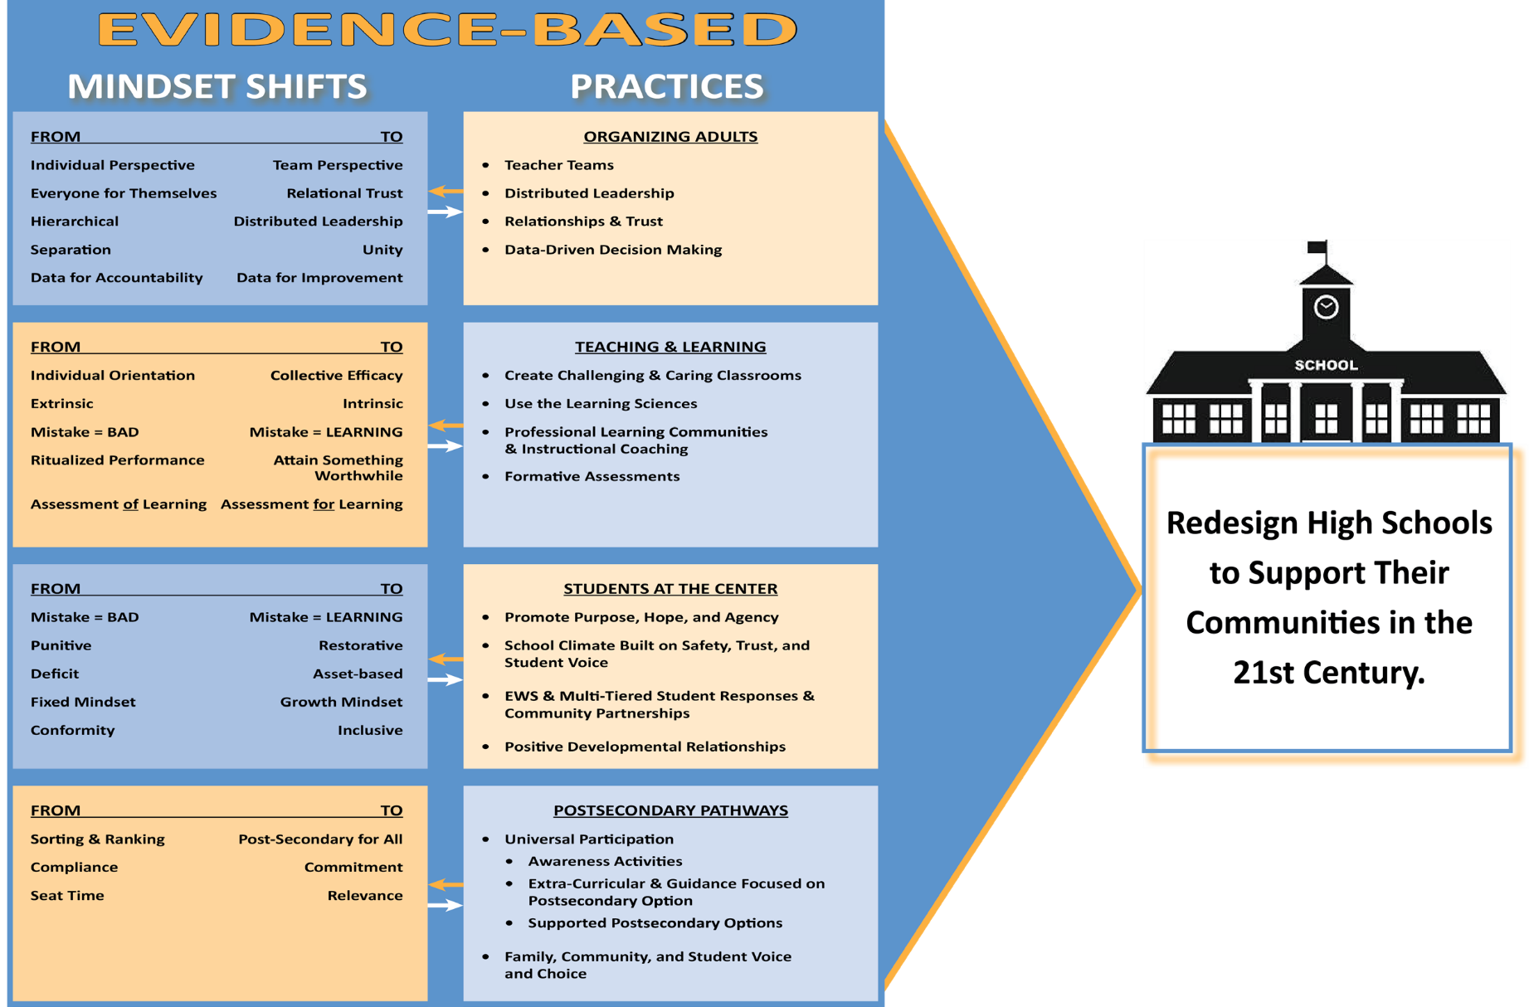
At a Glance

Using ESSA to Create High Schools that Help Communities Thrive in the 21st Century
- Hopeful, positive, future-orientated frame to design high schools for the 21st century rather than being seen as failed schools in need of reform
- Goal is not a high school diploma but strong pathways through high school to post-secondary and adult success for all students
- Evidence-based, but locally customized/orientated-not one way for all
- Address stress and scarcity through capacity building and technical assistance partners tightly aligned to community re-design vision and goals
- Break social isolation via school networks facing similar challenges, provide opportunity for school leaders to travel to see other possibilities
- In high needs communities, make redesigned high school the center of community economic
development and social integration efforts

1

Global Guiding Questions
How might we create a school where we all want to be?
- A school with stronger outcomes? A school that is filled with joy? A school that is hopeful?
How might we come to a common understanding of our shared opportunities and challenges?
How might we best utilize the different strengths of adults and students in the
school?
- How might we increase human resources in creative and low cost ways?
- How might we creatively involve our community in the process?

How might we create an environment where we are one with a sense of belonging given the context we are in?
- How might we build on the relationship strengths of adults and students?
- Share a time when your school environment made you and others in the school feel a strong sense of belonging?

How will our school culture support redesign opportunities?
- Where will we build in time and places for continuous reflection?

How might we embrace the conflict and ambiguity which is inherent in change?
Timeline

Mental Icebreakers/ Team Building Activities and Ongoing Cohort Collaboration/ Dialogue
(Yammer! and virtual
office hours)
Cohort Schools Develop Priorities and Strategies for Redesign
Seek Community Feedback

Cohort Schools Continue to Develop & Finalize Redesign Plan
(Hopkins support available)
May - October July 24 - 26 July - October October 23 - 25 November -

July Cohort Convening | Talent Development Secondary Support  (by request) | October Cohort Convening
2
January 2019

Who are We Designing For?
3

School Name:
School Demographics
Enrollment |  | Principal Tenure and Circumstances
Grade 9 Enrollment |  | Number of Teachers
Grade 10 Enrollment |  | Number of ELA Teachers
Grade 11 Enrollment |  | Number of Math Teachers
Grade 12 Enrollment |  | Number of Staff Total
% Free/Reduced Lunch |  | Number of 1st Year Teachers
% English Language Learners |  | Data Access
% Special Education |  | Current Significant Partners
% Economically Disadvantaged |  | Current and Recent Grads
% Caucasian
% African American
% Hispanic
% Native American
% Asian/Pacific Islander
% Other:

School Data (Previous Year: )
Grade 9 ELA On Track Rate |  | Gr . 9 State Assessment Meets/Exceeds
Grade 9 Math On Track Rate |  | Gr .10 State Assessment Meets/Exceeds
Grade 9 Attendance On Track |  | Gr .11 State Assessment Meets/Exceeds
Grade 9 On Track/Promotion Rate |  | Gr .12 State Assessment Meets/Exceeds
Grade 10 ELA On Track Rate |  | School Wide Tardiness Rate
Grade 10 Math On Track Rate |  | School Wide Attendance On Track
Grade 10 Attendance On Track |  | Average ACT/SAT Score
Grade 10 On Track/Promotion Rate |  | ADA
Grade 11 ELA On Track Rate |  | ISS Rate
Grade 11 Math On Track Rate |  | OSS Rate
Grade 11 Attendance On Track |  | Expulsion Rate
Grade 11 On Track/Promotion Rate
Grade 12 ELA On Track Rate
Grade 12 Math On Track Rate
Grade 12 Attendance On Track

Student Profiles
4
)

9th Grade | Student 1 | Student 2 | Student 3 | Student 4 | Student 5

12th Grade | Student 1 | Student 2 | Student 3 | Student 4 | Student 5

Data Statements or Observations
Enter Statements or Observations Here
5

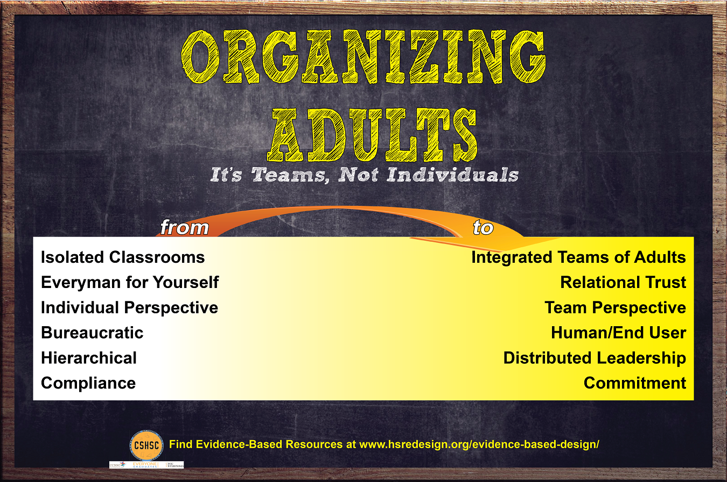
ORGANIZING ADULTS

Guiding Redesign Questions
Below are some guiding questions that may support your team in identifying evidence-based strategies to shape your developing high school redesign plan.
- How might we build on the current strengths and talents of our staff?
- How might we develop strong relationships between teachers, and between teachers and
administrators?
- How might we support the ongoing development of teachers AND LEADERS? How will you provide principal coaching/support in your school? How will you seek to utilize state-trained mentor teachers to build capacity in your school?
- How might we create a culture of data-driven decision making and make the data needed for sound decisions widely available?
- How might we ensure teachers and others have time to plan collaboratively?
- How might we form interdisciplinary teams of adults?
- How might we create a school master schedule and expanded learning opportunities that supports our redesign and enables the implementation of evidence-based practices in organizing adults, supporting students, teaching and learning and postsecondary pathways?
- How do you plan to effectively attract, recruit, and retain teachers and administrators, including any planned partnerships?

6

Evidence-Based Practice
Teacher Teams: Interdisciplinary, working with cohorts of students
Areas of Strength |  | STRATEGIES
Mindset Challenges
Big Idea to Explore
with Stakeholders
Evidence-Based Practice
Distributed Leadership: Staff play multiple roles and decision making is dispersed
Areas of Strength |  | STRATEGIES  7
Mindset Challenges
Big Idea to Explore
with Stakeholders

Evidence-Based Practice
Leadership Development: Opportunities and pathways for teacher leadership
Areas of Strength |  | STRATEGIES
Mindset Challenges
Big Idea to Explore
with Stakeholders
Evidence-Based Practice
Relationships and Trust: Strong relationships between teachers and admin & teachers
Areas of Strength |  | STRATEGIES
Mindset Challenges
Big Idea to Explore
with Stakeholders

8

Evidence-Based Practice
Data Driven Decision Making: Real-time, predictive data about students being used to make team intervention decisions and drive school-wide decisions and priorities
Areas of Strength |  | STRATEGIES
Mindset Challenges
Big Idea to Explore
with Stakeholders

Notes, Questions & Wonderings:

9

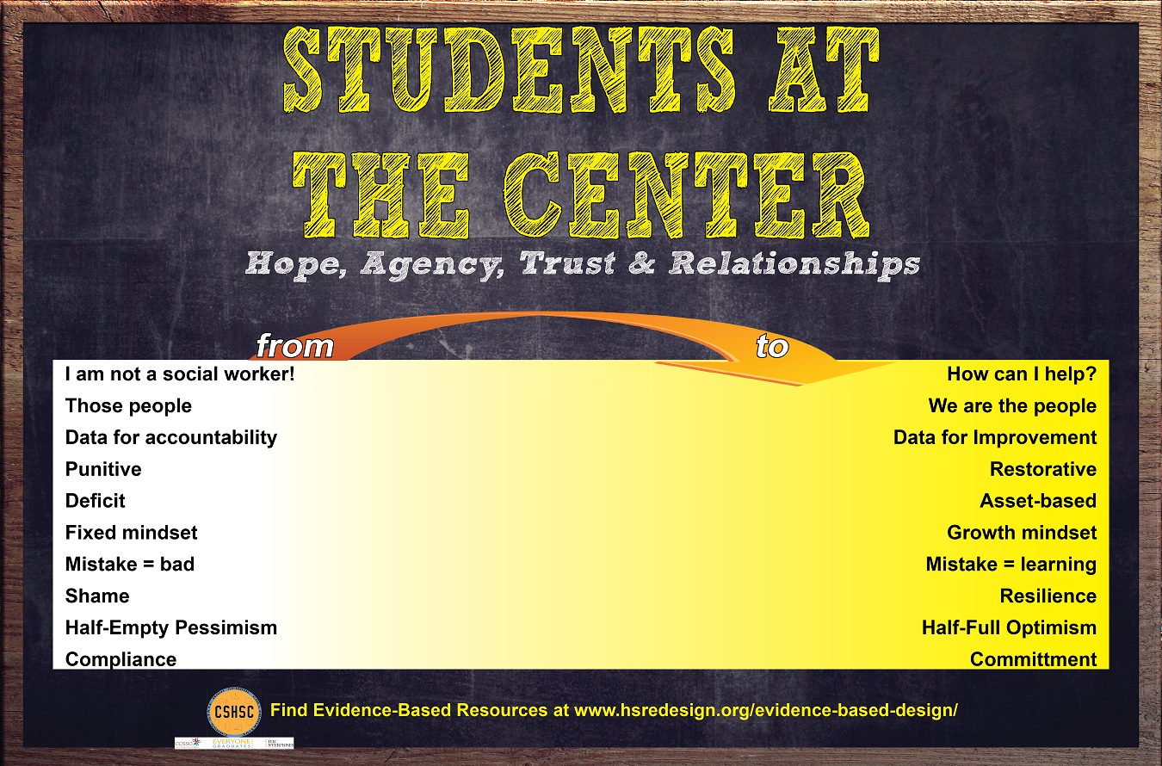
STUDENTS AT THE CENTER

Guiding Redesign Questions
Below are some guiding questions that may support your team in identifying evidence-based strategies to shape your developing high school redesign plan.
- How might we make room for and listen to student voice in our redesign efforts?
- How might we create a school environment that supports the development of positive
relationships between students, and students and staff?
- How might we develop and then sustain structures that recognize/celebrate students and staff?
- How might we assign/schedule students so they can be known by the adults in our school?
- How might we shape student experiences to enable them to experience hope, agency,
and purpose?
- How might we embrace Restorative Practices or other evidence-based frameworks that support positive voice, choice, and belonging at our school for adults and kids?
- How might we adapt and improve our existing student support strategies to create a powerful early warning and multi-tiered support system that continually monitors all students’ progress and keeps them on track to postsecondary success?

10

Evidence-Based Practice
Positive developmental relationships with adults.
Areas of Strength |  | STRATEGIES
Mindset Challenges
Big Idea to Explore
with Stakeholders
Evidence-Based Practice
Early Warning and multi-tiered student response systems and community supports
Areas of Strength |  | STRATEGIES  11
Mindset Challenges
Big Idea to Explore
with Stakeholders

Evidence-Based Practice
Building hope, agency, and purpose.
Areas of Strength |  | STRATEGIES
Mindset Challenges
Big Idea to Explore
with Stakeholders
Evidence-Based Practice Restorative practices
Areas of Strength |  | STRATEGIES
Mindset Challenges
Big Idea to Explore
with Stakeholders

12

Notes, Questions & Wonderings:

13

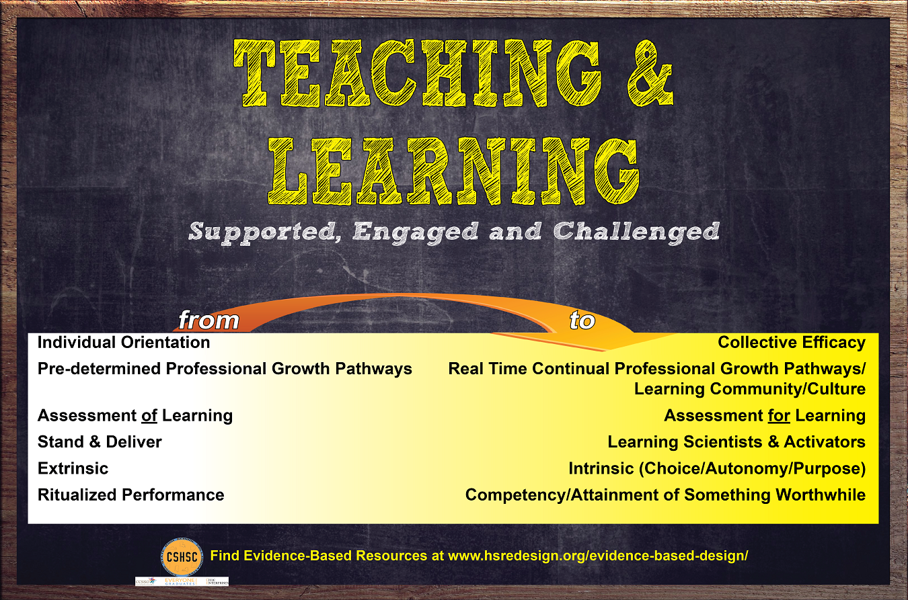
TEACHING & LEARNING

Guiding Redesign Questions
Below are some guiding questions that may support your team in identifying evidence-based strategies to shape
your developing high school redesign plan.
- How might we build adult capacity in our school and community to create learning environments that balance challenging students to achieve at high levels with a sense of caring and support?
- What high quality curriculum will your schools implement for each core subject
area?
- How will your school monitor and improve implementation over time?
- What partners will your school work with to provide both initial and ongoing professional development for both new and returning teachers?
- What structures will your school use to ensure effective, collaborative, and curriculum-driven planning and reflection?

14

Evidence-Based Practice Choice of high quality curricula
Areas of Strength |  | STRATEGIES
Mindset Challenges
Big Idea to Explore
with Stakeholders
Evidence-Based Practice
Strong curriculum implementation with fidelity and structures to support ongoing
implementation monitoring
Areas of Strength |  | STRATEGIES  15
Mindset Challenges
Big Idea to Explore
with Stakeholders

Evidence-Based Practice
Focus on building teacher capacity through high quality PD, PLCs, coaching and supports
Areas of Strength |  | STRATEGIES
Mindset Challenges
Big Idea to Explore
with Stakeholders
Evidence-Based Practice
Balancing challenge and caring in the classroom
Areas of Strength |  | STRATEGIES
Mindset Challenges
Big Idea to Explore
with Stakeholders

16

Notes, Questions & Wonderings:

17

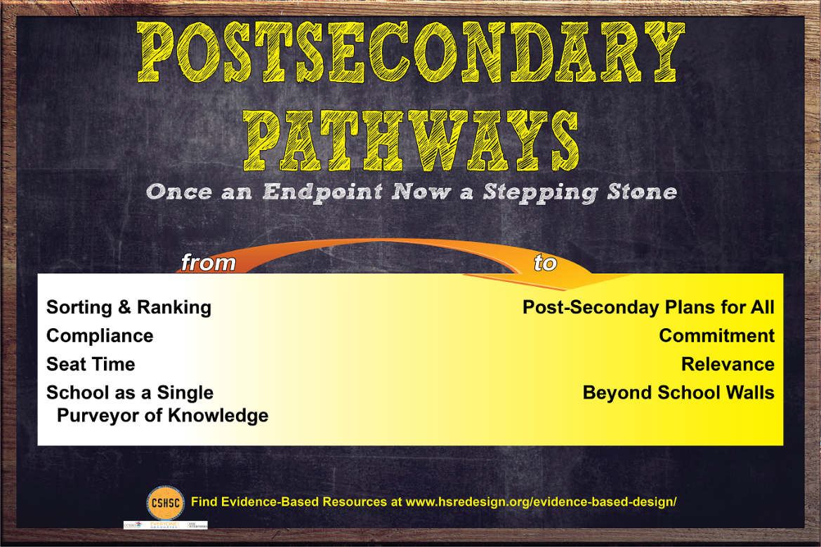
POSTSECONDARY PATHWAYS

Guiding Redesign Questions
Below are some guiding questions that may support your team in identifying evidence-based strategies to shape your developing high school redesign plan.
- How might we create opportunities for work-based learning, job shadowing, and internships at the scale needed?
- What activities are being implemented to ensure students have access to experiences that will prepare them for college and/or a career, and how might we assess competencies attained in those experiences?
- How might we support ongoing college and career planning programming that starts in freshman year, including family awareness/communication, and college admissions counseling?
- How might we think about career pathways and personalized postsecondary journeys for students? How could drop out prevention programs connect to and support those efforts?
- How might we incorporate student/family voice and choice in postsecondary planning?
- How might we provide rich universal school experiences (electives, extra-curricular
activities, etc.) for all students?
- What Jump Start Statewide Pathways are available that promote post-graduation
preparation? What is your statewide credential attainment goal?
- What funded college credit opportunities/courses are available to students? Who are the partners/entities providing access to college credit opportunities/courses?

18

Evidence-Based Practice
Choice of pathway is up to student and family. Universal participation for access for all.
Areas of Strength |  | STRATEGIES
Mindset Challenges
Big Idea to Explore
with Stakeholders
Evidence-Based Practice All students are supported to develop and execute a comprehensive plan that leads to college and career
Areas of Strength |  | STRATEGIES  19
Mindset Challenges
Big Idea to Explore
with Stakeholders

Evidence-Based Practice
Integration of technical and academic content. Integrating academic content into our CTE courses and career concepts in our academic courses
Areas of Strength |  | STRATEGIES
Mindset Challenges
Big Idea to Explore
with Stakeholders
Evidence-Based Practice
Dual enrollment/Early College/AP–IB. Ability to earn credit in a college or career
technical certification program
Areas of Strength |  | STRATEGIES
Mindset Challenges
Big Idea to Explore
with Stakeholders
20

Notes, Questions & Wonderings:

Our commitment to seek community feedback on redesign.

21

