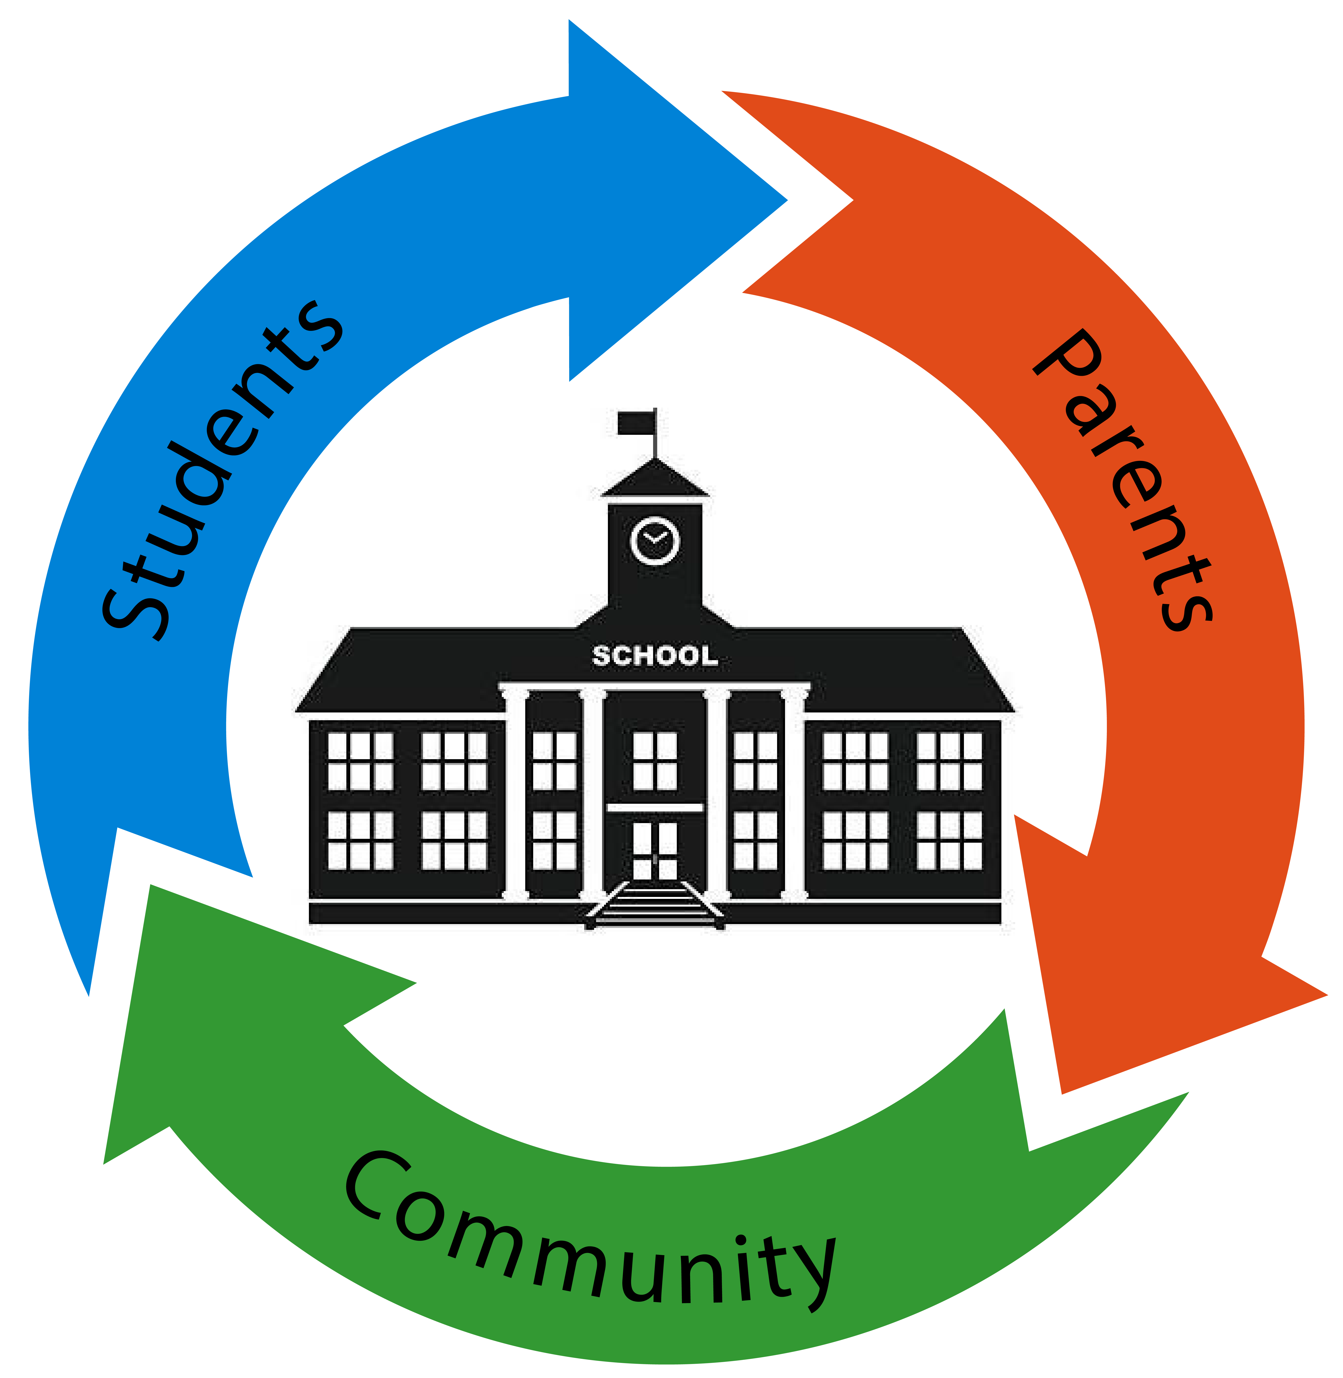Using ESSA to Redesign High Schools to Support Their Communities in the 21st Century

- 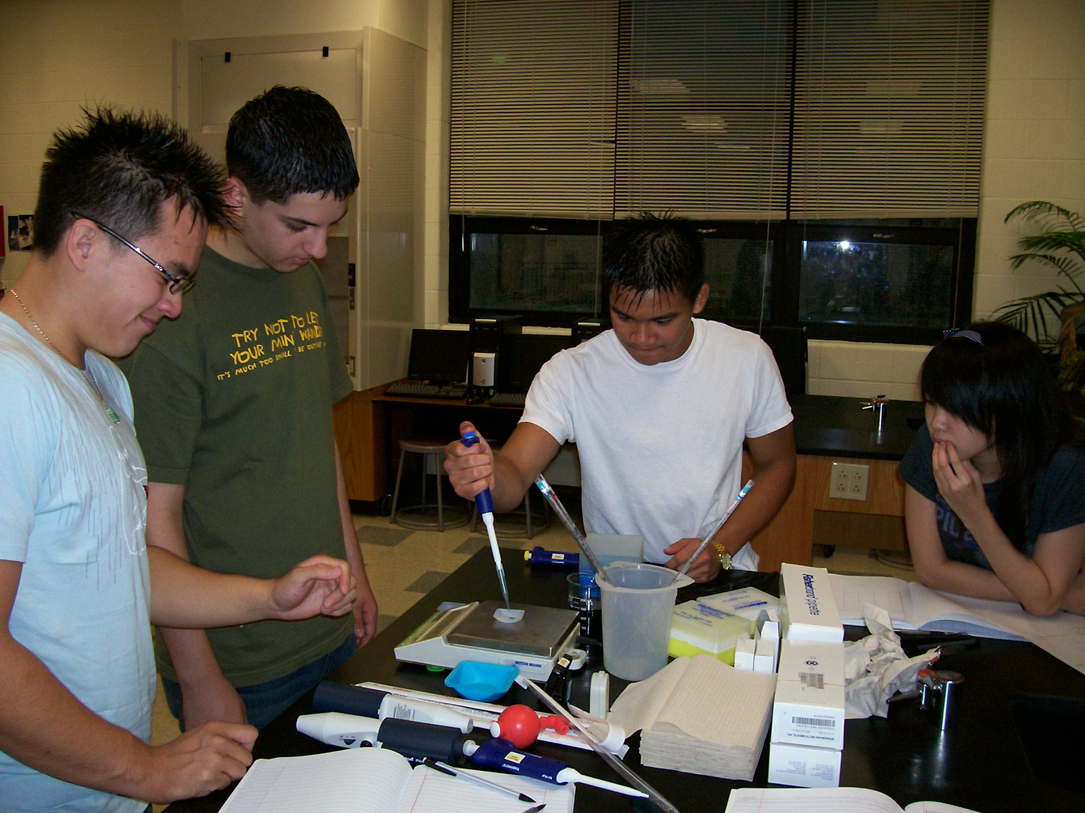Hopeful, positive, future-orientated framework to design high schools for the 21st century rather than being seen as failed schools in need of reform.
- Goal is not a high school diploma but strong pathways through high school to postsecondary and adult success for all students.
- Evidence-based, but locally customized/orientated—not one way for all.
- 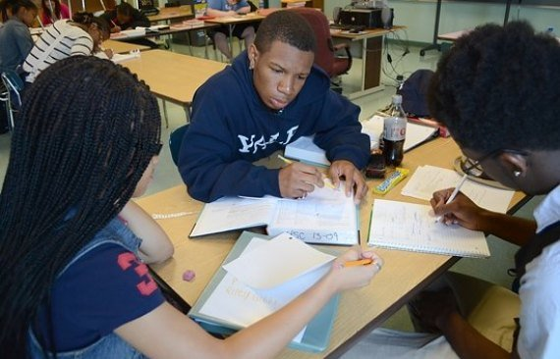Address stress and scarcity through capacity building and technical assistance partners tightly aligned to community redesign vision and goals.
- Break social isolation via school networks facing similar challenges, provide opportunities for school leaders to travel to see other possibilities.
- In high-needs communities make the redesigned high school the center of community economic development and social integration efforts.

Global Guiding Questions

How might we create a school where everyone wants to be?
- A school that is filled with joy? A school that is hopeful?
How might we come to a common understanding of our shared opportunities and challenges?
- How might we recognize our students as a community resource?
How might we best utilize the different strengths of adults and students in the school?
- How might we increase human resources in creative and innovative ways?
- How might we creatively involve our community in the process?
How might we create an environment where everyone feels a sense of belonging?
- How might we build on the relationship strengths of adults and students?
How will our school culture support redesign opportunities?
- Where will we build in time and places for continuous reflection?
- How will we embrace the conflict and ambiguity which is inherent in change?
How might we see our schools as engines of economic innovation?

Redesign Sequence of Events
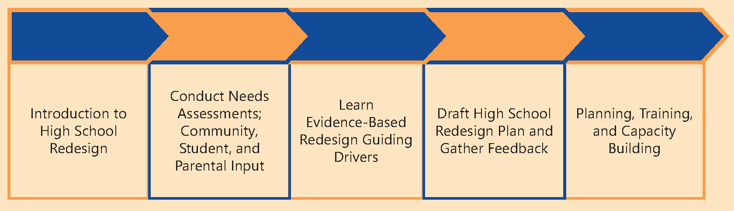

Shifting to Evidence-Based Practices
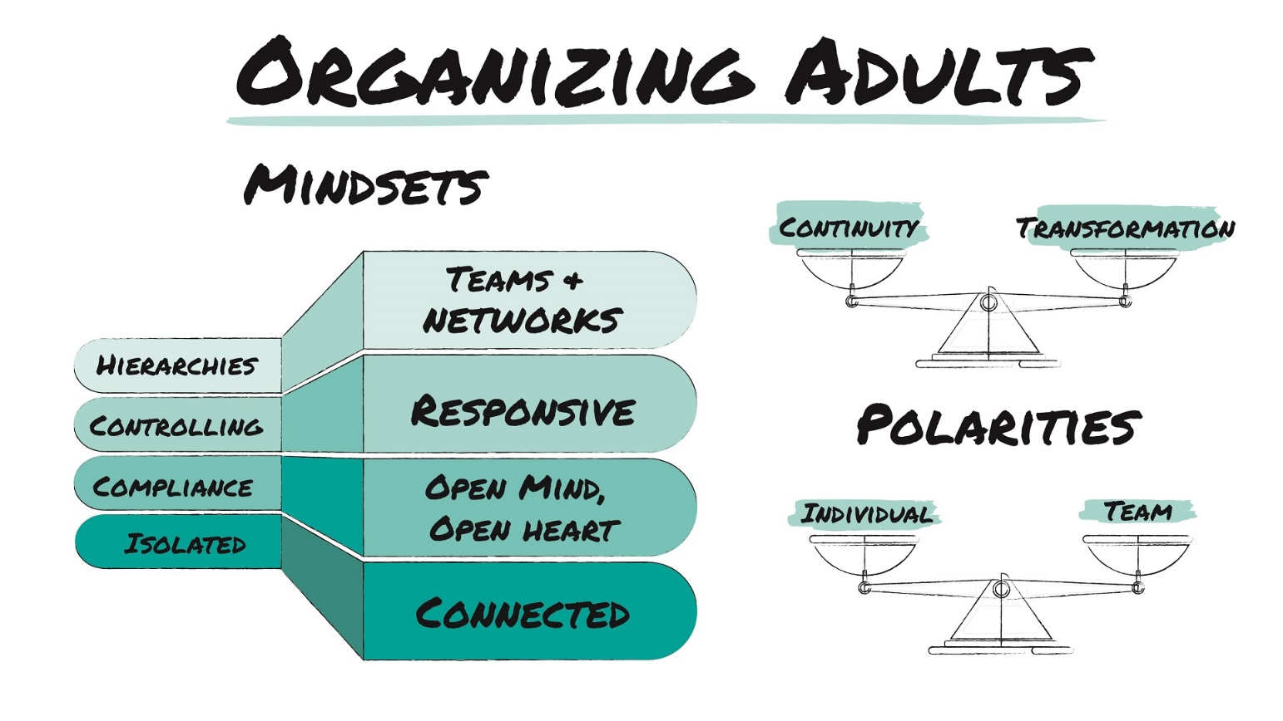
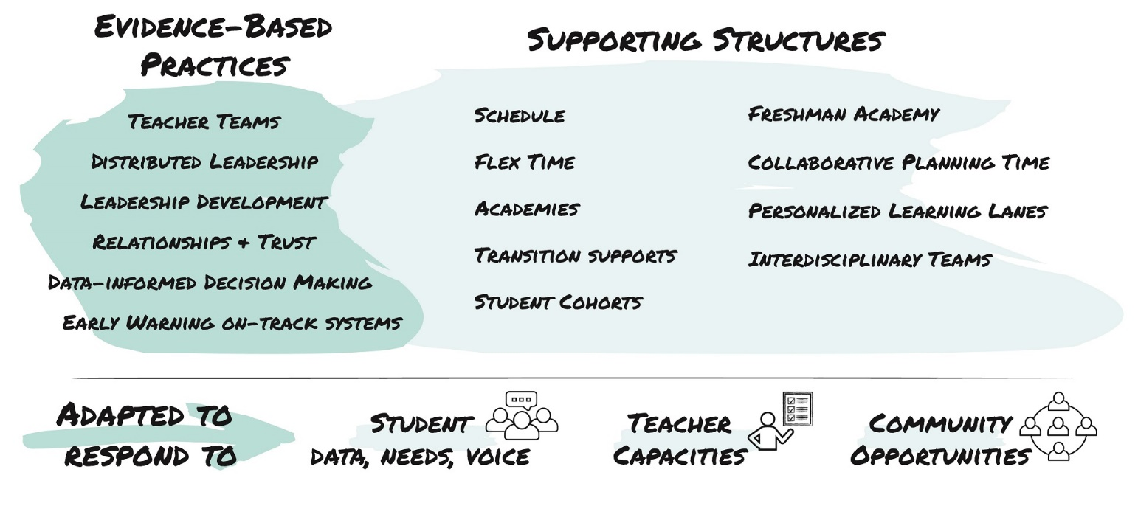

Shifting to Evidence-Based Practices
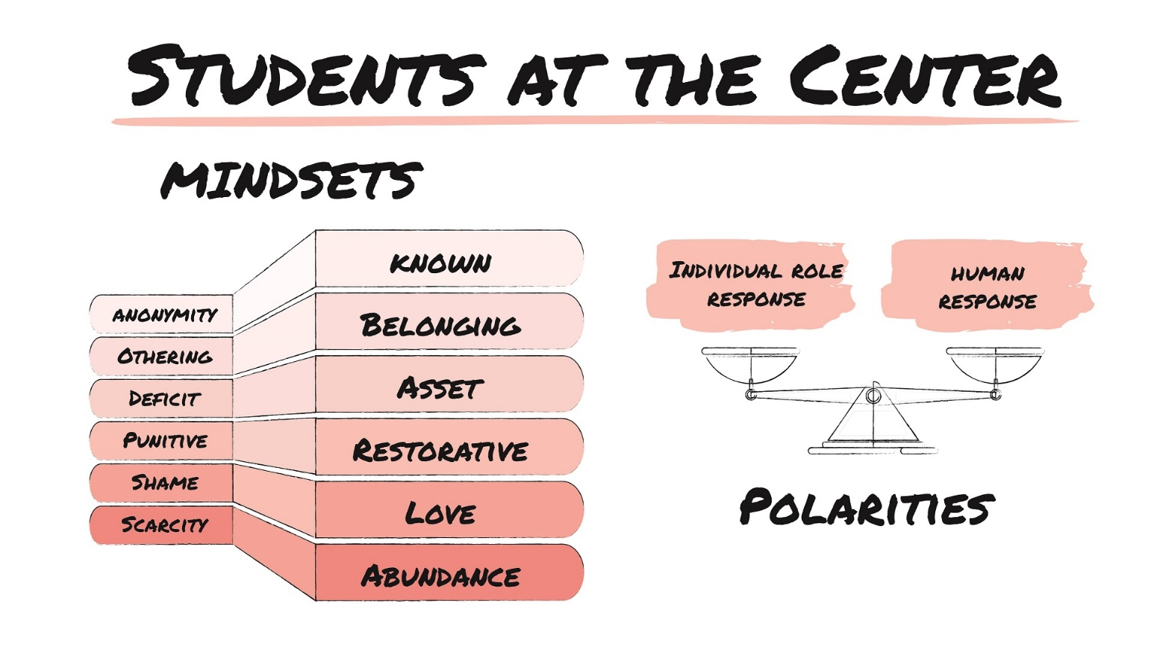
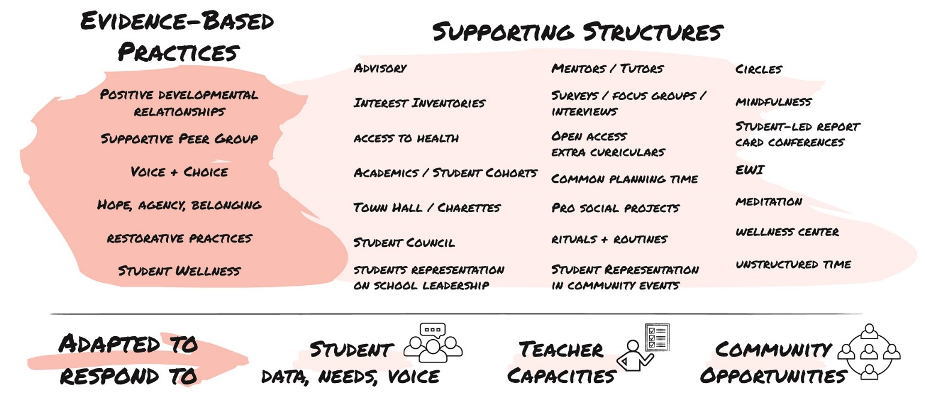

Shifting to Evidence-Based Practices
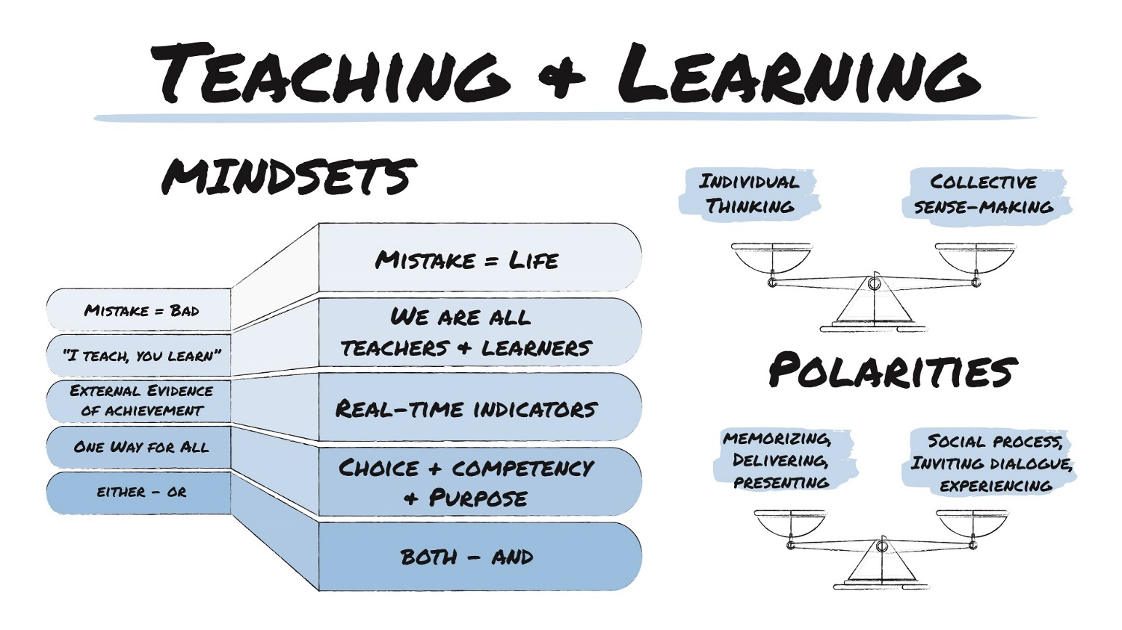
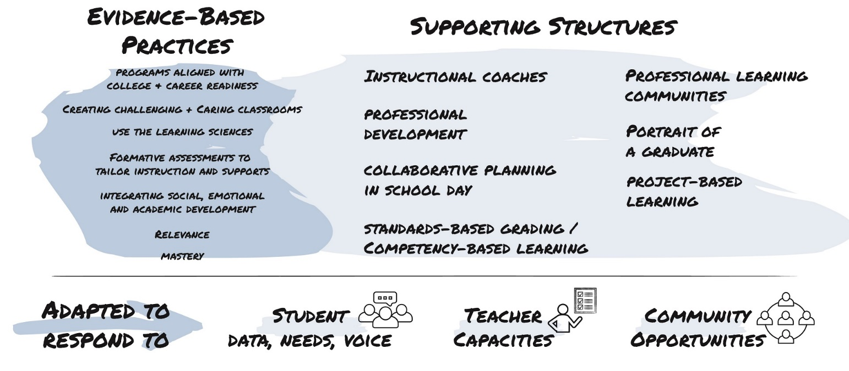

Shifting to Evidence-Based Practices
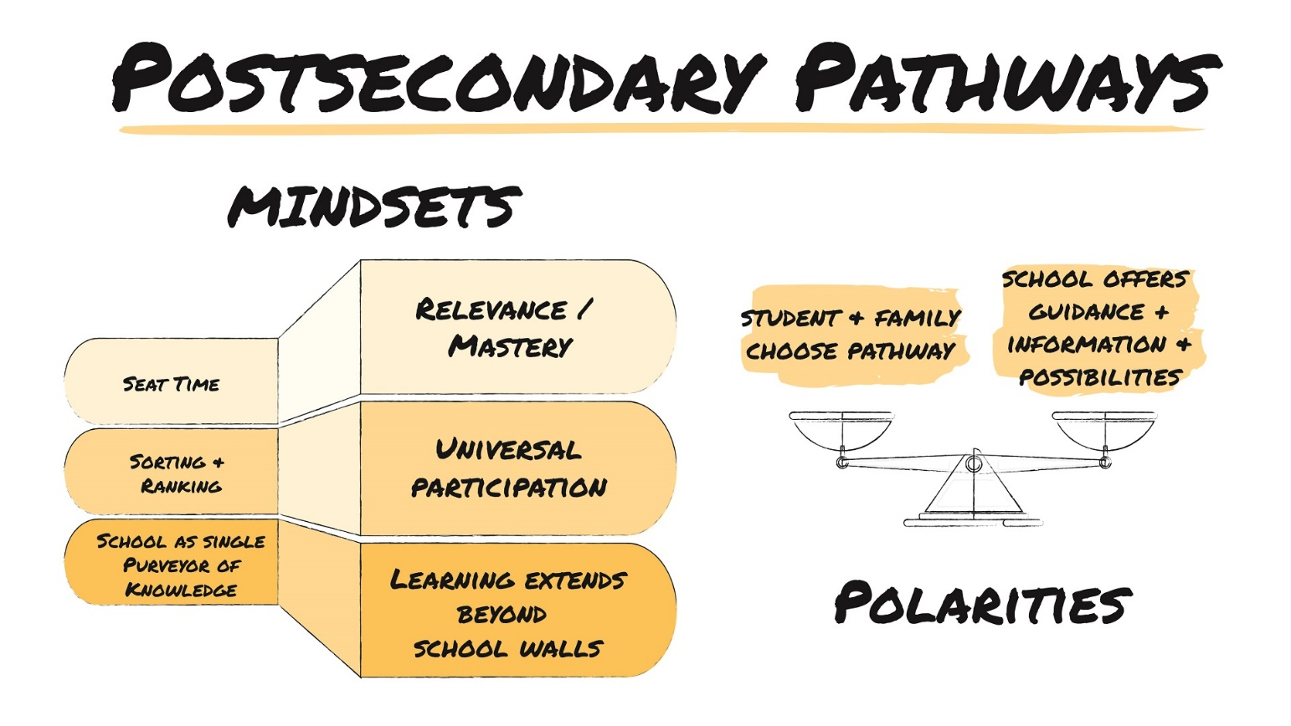
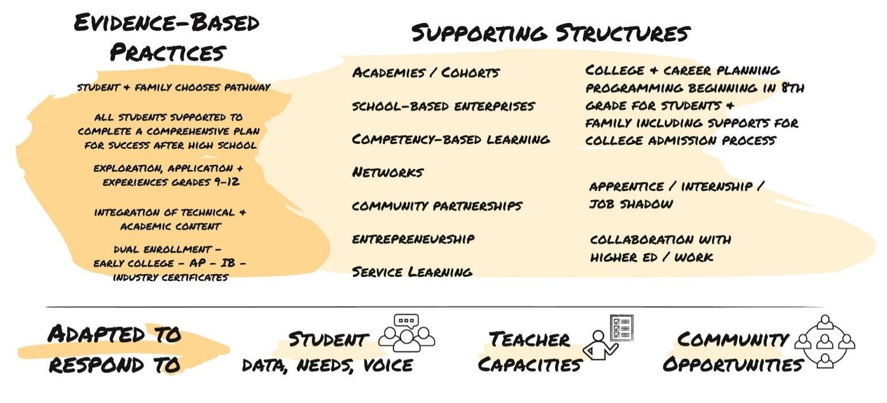

Who Are We Designing For—Student Profiles
9th Grade—Student 1
9th Grade—Student 2
9th Grade—Student 3
9th Grade—Student 4

Who Are We Designing For—Student Profiles
12th Grade—Student 1
12th Grade—Student 2
12th Grade—Student 3
12th Grade—Student 4

Who Are We Designing For—Demographic Information
Use your school’s data to help guide your redesign. We’ve started off with some basic questions to help guide your team through this section. Feel free to add any data points to the ones provided.
Who are the students in our school? | Where do our graduates go?
Who are our entering ninth graders? | Who is in our community?

Who are the students in our school?
Enrollment
Grade 9 Enrollment |  | % Economically Disadvantaged
Grade 10 Enrollment |  | % Caucasian
Grade 11 Enrollment |  | % African American
Grade 12 Enrollment |  | % Hispanic
% Free/Reduced Lunch |  | % Native American
% English Language Learners |  | % Asian/Pacific Islander
% Special Education |  | % Other:
Additional Data
Principal Tenure & Circumstances |  | ADA
# of Teachers |  | Average ACT/SAT Score
# of Staff Total |  | ISS Rate
# of First-Year Teachers |  | OSS Rate
School-wide Tardiness Rate |  | Expulsion Rate
Chronic Absentee Rate |  | Current Significant Partners
State Assessment Outcomes |  | - Youth & Social Svc. Agencies
 |  | - After School Programs, etc.
 |  | - Internships
 |  | - Non-profit Partnerships
Who Are We Designing For—Demographic Information
Who are our entering ninth graders?
8th Grade Attendance Rate |  | Suspension Rate
GPA |  | Test Scores
Overage for Grade
Where do our graduates go?
Postsecondary |  | Military
Two-year College |  | Employment
Four-year College
Who is in our community?
Significant Employers |  | Significant Non-Profits
Significant Grass Roots Orgs. |  | What is the closest higher-learning institution?
Where is the closest higher-learning institution

Who Are We Designing For—Community Feedback
on Redesign

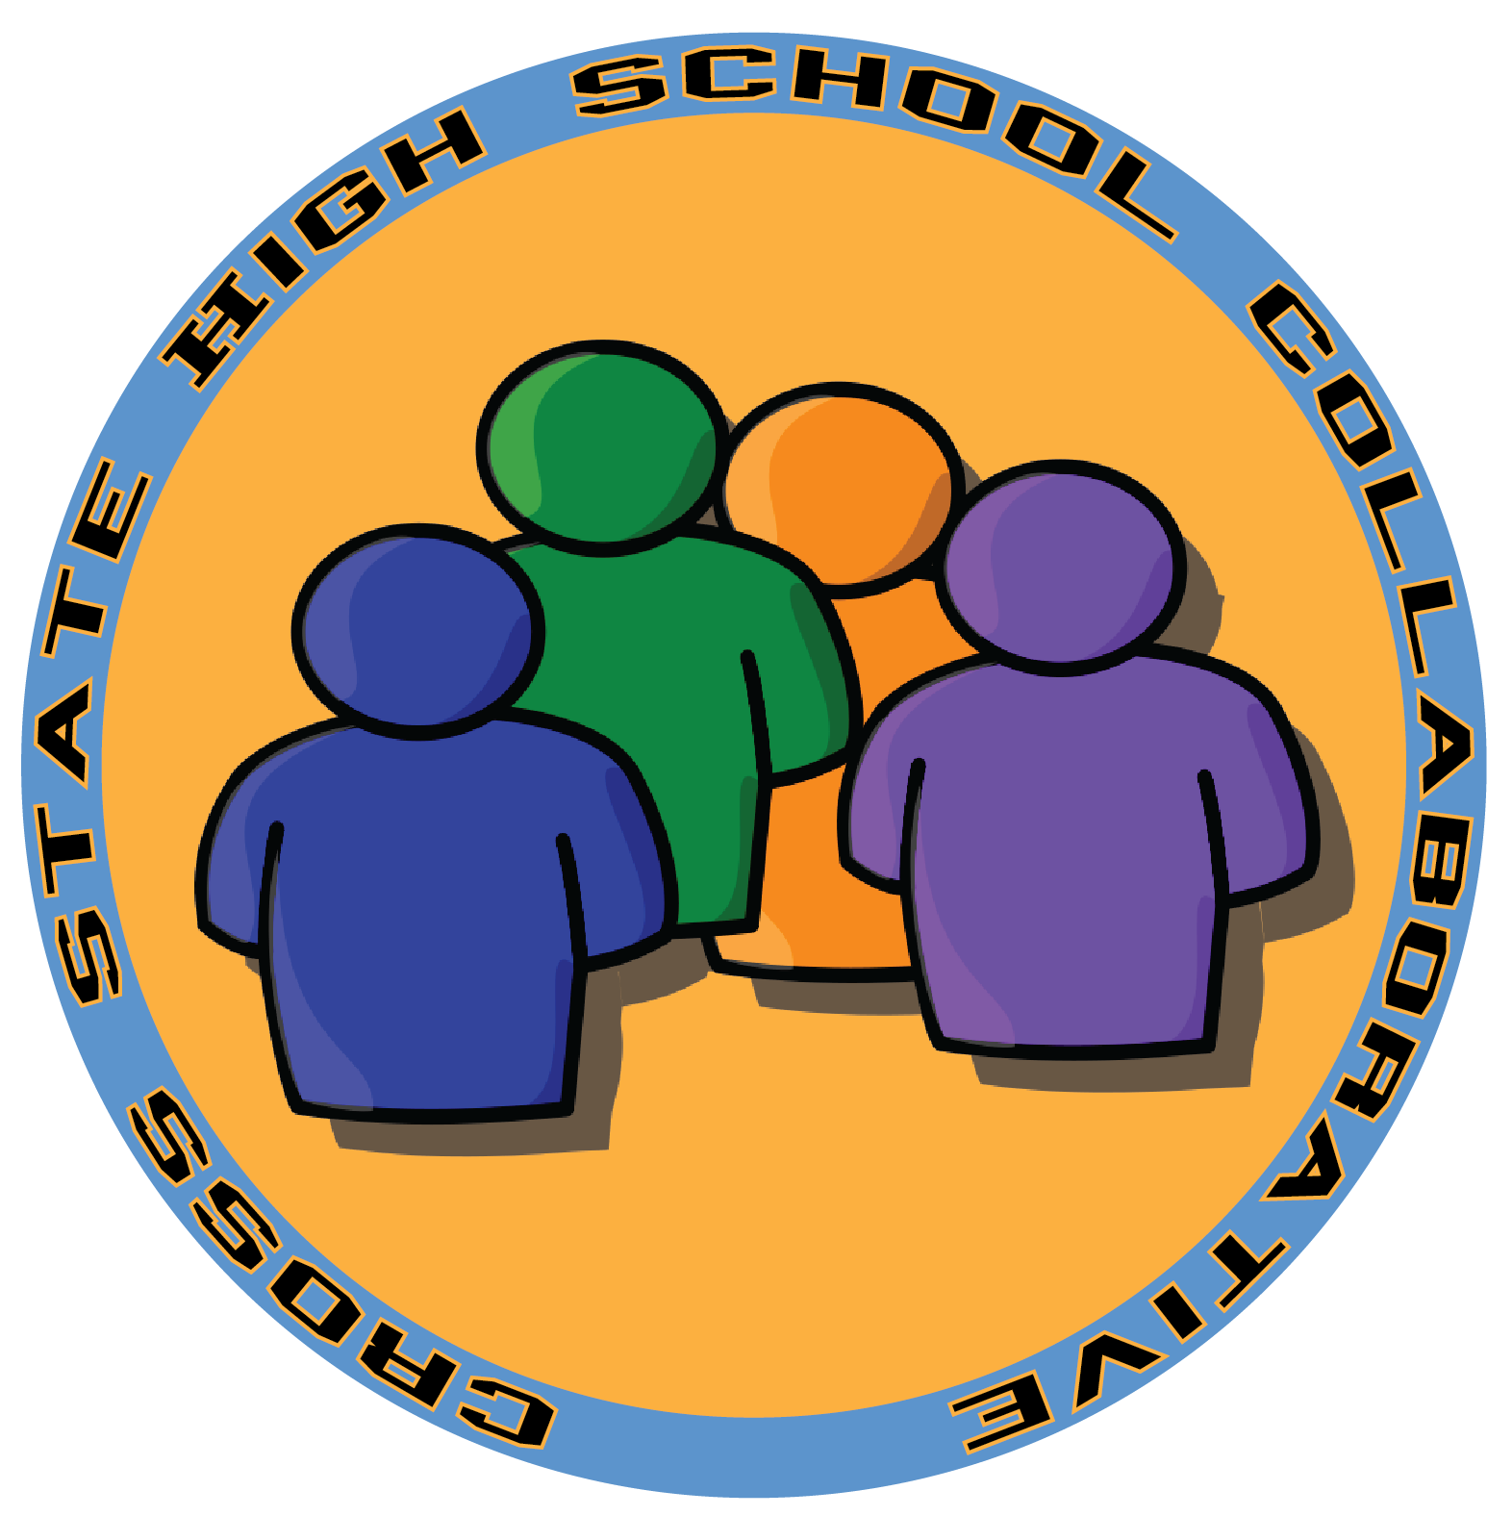Organizing Adults
Click Here for Additional Redesign Resources
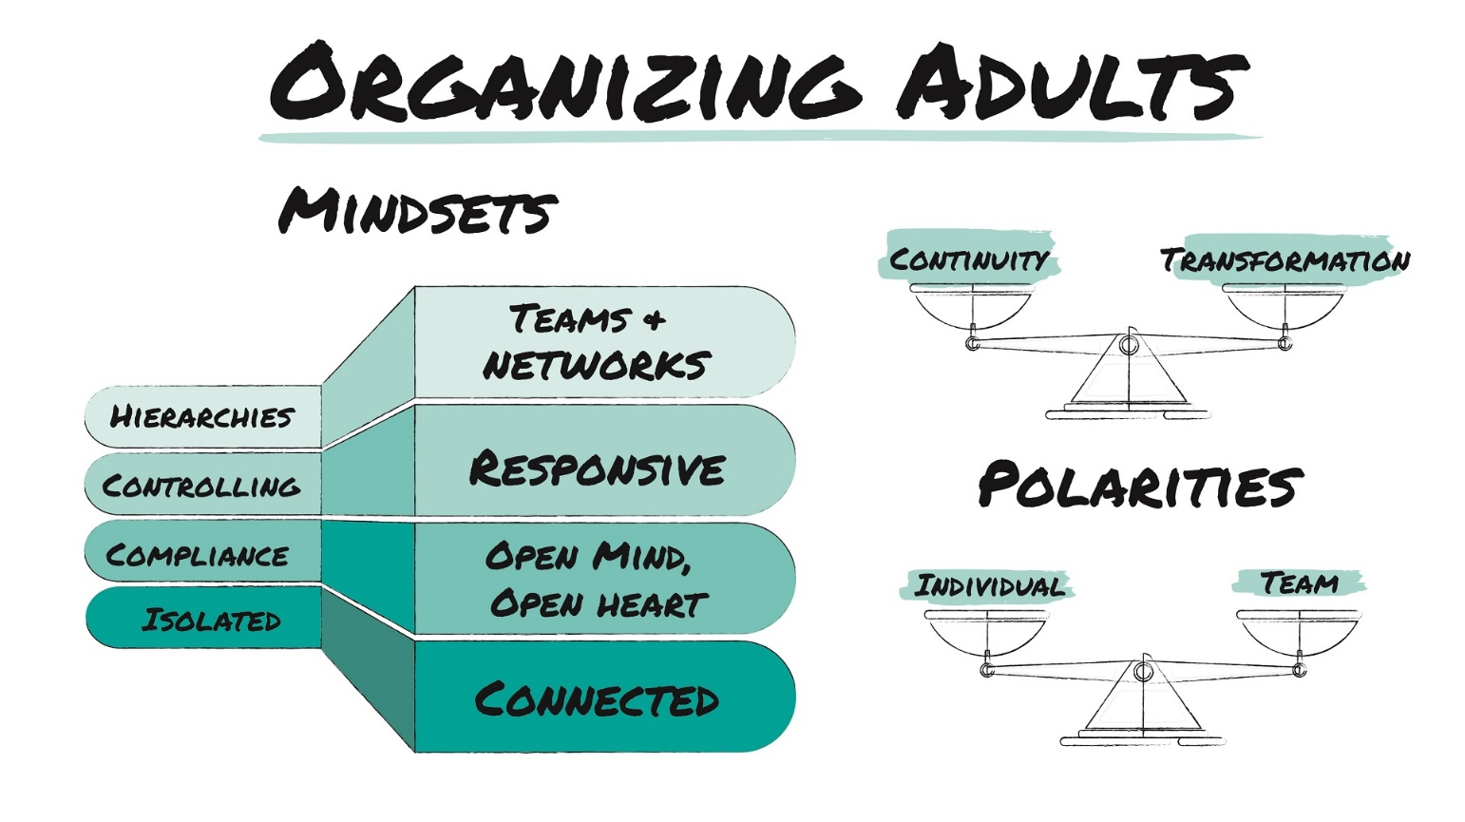
Guiding Redesign Questions
Below are some guiding questions that may support your team in identifying evidence-based strategies to shape your developing high school redesign plan.
- How might we build on the current strengths and talents of our staff?
- How might we develop strong relationships between teachers and between teachers and administrators?
- How might we create a school master schedule that supports our redesign and enables the implementation of evidence-based practices in organizing adults, supporting students, teaching and learning, and postsecondary pathways?
- How might we form interdisciplinary teams of adults?
- How might we ensure teachers and others have time to work collaboratively while supporting student success?
- How might we create a culture of data-driven decision making and make the data needed for sound decisions widely available so that all decisions are made closest to the students and teachers impacted?
- How might we adapt and improve our existing student support strategies to create a powerful early warning, multi-tiered support system that monitors all students progress continually and keeps them on track to postsecondary success?
- How might we support the ongoing development of teachers across all domains of the work?

Evidence-Based Practice—Teacher Teams: Interdisciplinary, working with cohorts of students
Areas We Can Build Upon |  | Strategies
Mindset Explorations |  | Strategies
Big Idea to Explore with Stakeholders |  | Strategies
Evidence-Based Practice—Distributive Leadership: Staff play multiple roles and
decision making is dispersed
Areas We Can Build Upon |  | Strategies
Mindset Explorations |  | Strategies
Big Idea to Explore with Stakeholders |  | Strategies
Evidence-Based Practice—Leadership Development: Opportunities and pathways
for teacher leadership
Areas We Can Build Upon |  | Strategies
Mindset Explorations |  | Strategies
Big Idea to Explore with Stakeholders |  | Strategies
Evidence-Based Practice—Relationships & Trust: Strong relationships between
teachers & administrators
Areas We Can Build Upon |  | Strategies
Mindset Explorations |  | Strategies
Big Idea to Explore with Stakeholders |  | Strategies
Evidence-Based Practice—Data Driven Decision Making: Real-time, predictive data about students being used to make team intervention decisions and drive school-wide decisions and priorities
Areas We Can Build Upon |  | Strategies
Mindset Explorations |  | Strategies
Big Idea to Explore with Stakeholders |  | Strategies
Notes, Question & Wonderings

Students at the Center
Click Here for Additional Redesign Resources
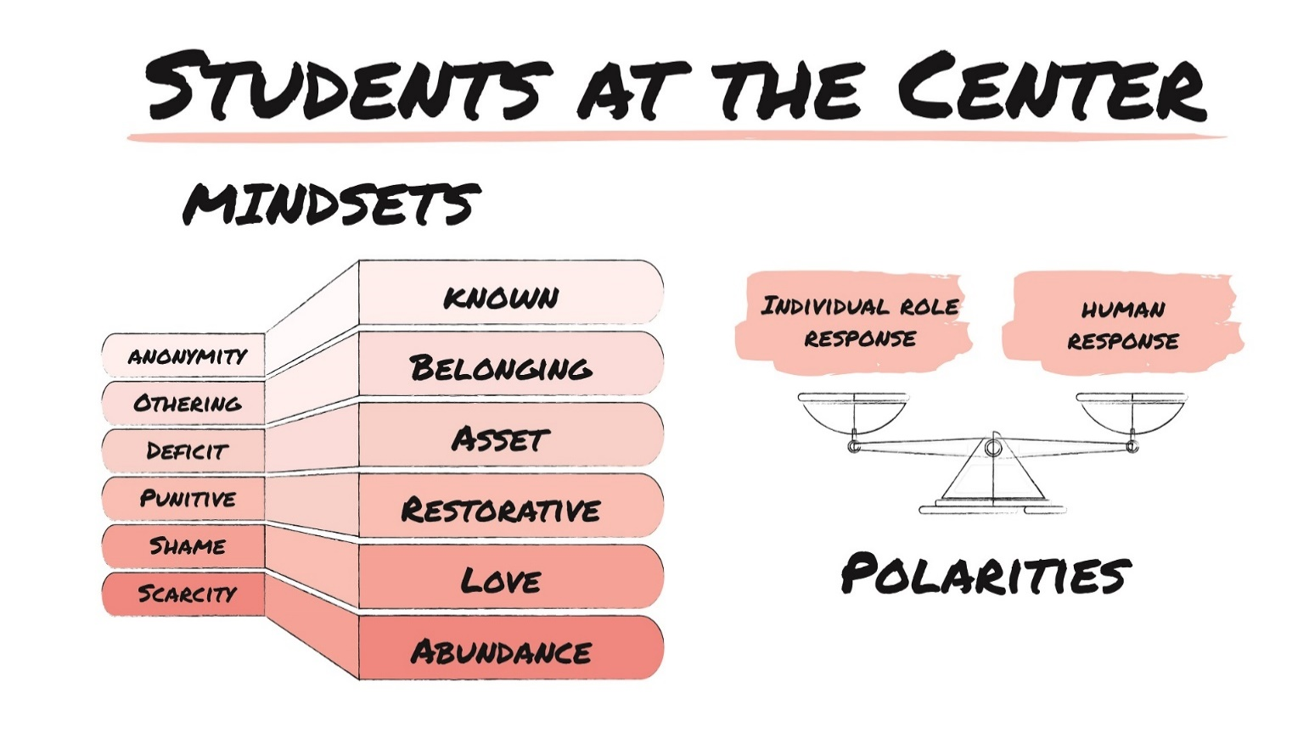

Guiding Redesign Questions
Below are some guiding questions that may support your team in identifying evidence-based strategies to shape your developing high school redesign plan.
- How might we make room for and listen to student voice in our redesign efforts?
- How might we create a school environment which supports the development of positive relationships between students and students, students and staff, and allows all students and adults to feel known and valued?
- How might we develop and then sustain structures that recognize/celebrate students and staff?
- How might we shape student experiences to enable them to experience hope, agency, and purpose?
- How might we embrace Restorative Practices?
- How might we learn how to balance student choice and voice with structure and support?
- How might we enhance the capacities of adults and students for openness, listening, empathy, and patience to create a culture of belonging?

Evidence-Based Practice—Positive developmental relationships with adults
Areas We Can Build Upon |  | Strategies
Mindset Explorations |  | Strategies
Big Idea to Explore with Stakeholders |  | Strategies
Evidence-Based Practice—Early Warning and multi-tiered student response systems
and community supports
Areas We Can Build Upon |  | Strategies
Mindset Explorations |  | Strategies
Big Idea to Explore with Stakeholders |  | Strategies
Evidence-Based Practice—Building hope, agency, and purpose
Areas We Can Build Upon |  | Strategies
Mindset Explorations |  | Strategies
Big Idea to Explore with Stakeholders |  | Strategies
Evidence-Based Practice—School climate built upon safety, trust, and student voice
(e.g., use restorative practices)
Areas We Can Build Upon |  | Strategies
Mindset Explorations |  | Strategies
Big Idea to Explore with Stakeholders |  | Strategies
Notes, Question & Wonderings

Teaching & Learning
Click Here for Additional Redesign Resources

Guiding Redesign Questions
Below are some guiding questions that may support your team in identifying evidence-based strategies to shape your developing high school redesign plan.
- How might we build adult capacity in our school and community to create learning environments which balance challenging students to achieve at high levels with a sense of caring and support?
- How might we shift from instructional practices to learning sciences informed practices?
- How might we embrace the importance of culturally responsive instruction in all aspects of learning?
- How might we change our perception from “learning enough to pass and mistakes are bad” to “mistakes are how we learn on the path to competency-based achievement.”
- How might we build a formative assessment culture to tailor instruction and supports?
- How might we provide professional development supports, mindset shifts, and skill-building opportunities necessary to teach today’s learners and to empower them for the future?

Evidence-Based Practice—Create challenging & caring classrooms; instructional teams use standards-aligned units of instruction for each subject and grade level, while engineering student engagement and providing student supports
Areas We Can Build Upon |  | Strategies
Mindset Explorations |  | Strategies
Big Idea to Explore with Stakeholders |  | Strategies
Evidence-Based Practice—Use the learning sciences
Areas We Can Build Upon |  | Strategies
Mindset Explorations |  | Strategies
Big Idea to Explore with Stakeholders |  | Strategies
Evidence-Based Practice—Use professional learning communities (PLCs)
and instructional coaching
Areas We Can Build Upon |  | Strategies
Mindset Explorations |  | Strategies
Big Idea to Explore with Stakeholders |  | Strategies
Evidence-Based Practice—Formative assessments
Areas We Can Build Upon |  | Strategies
Mindset Explorations |  | Strategies
Big Idea to Explore with Stakeholders |  | Strategies
Notes, Question & Wonderings

Postsecondary Pathways
Click Here for Additional Redesign Resources
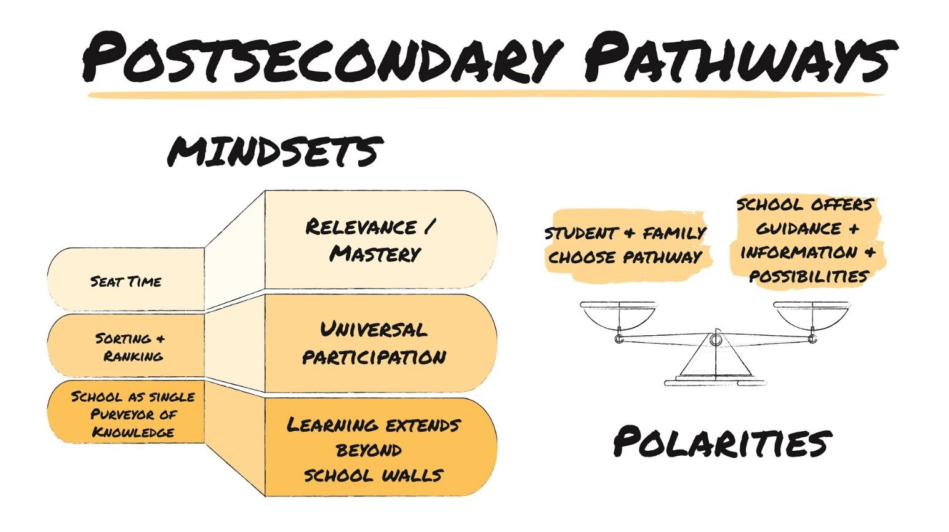
Guiding Redesign Questions
Below are some guiding questions that may support your team in identifying evidence-based strategies to shape your developing high school redesign plan.
- How might we provide rich universal school experiences (electives, extra-curricular activities, etc.) for all students?
- How might we move away from seat time toward competency while taking advantage of learning that happens beyond the school walls?
- How might we incorporate student/family voice and choice in postsecondary planning?
- How might we create opportunities for work-based learning, job shadowing, internships, and college explorations at the scale needed?
- How might we rethink career pathways and personalized postsecondary journeys for students?
- How might we support ongoing college and career planning programming that starts in freshman year, including family awareness/communication, and college admissions counseling?
- How might we connect students to social networks that support trust building and align to adult success?
- How might high school be more like postsecondary experiences?

Evidence-Based Practice—Choice of pathway is up to student and family.
Universal participation for access for everyone
Areas We Can Build Upon |  | Strategies
Mindset Explorations |  | Strategies
Big Idea to Explore with Stakeholders |  | Strategies
Evidence-Based Practice—All students are supported to complete a comprehensive plan
after high school
Areas We Can Build Upon |  | Strategies
Mindset Explorations |  | Strategies
Big Idea to Explore with Stakeholders |  | Strategies
Evidence-Based Practice—Integration of technical and academic content. Integrating academic content into our CTE courses and career concepts in our academic courses
Areas We Can Build Upon |  | Strategies
Mindset Explorations |  | Strategies
Big Idea to Explore with Stakeholders |  | Strategies
Evidence-Based Practice—Dual enrollment/Early College/AP–IB; ability to earn credit in a college or career technical certification program
Areas We Can Build Upon |  | Strategies
Mindset Explorations |  | Strategies
Big Idea to Explore with Stakeholders |  | Strategies
Notes, Question & Wonderings

